Technical Design Document

Request for Certificate of Compliance

Submission & Commission Decision Management System (SCDMS)

DOCUMENT CONTROL
Prepared by | Herman Tevilili  Innovation Policy Development Unit  Office of the Public Service Commission
Submitted to | Department of Digital and Communications Technology
Date | May 2026

1. Executive Summary
The Innovation and Policy Development Unit (IPDU) is developing the Submission & Commission Decision Management System (SCDMS) - an internal digital platform to replace the manual, paper-based process by which Line Ministry HR departments send their submissions to the OPSC for commission deliberation and decision.
This document constitutes the Technical Design Document submitted to the Department of Digital and Communications Technology (DCDT) in fulfillment of Section 3(f) of the Digital Transformation Act No. 42 of 2025, formally requesting a Certificate of Compliance (CoC) before full development and deployment proceeds.
The SCDMS is developed entirely in-house by the IPDU. No external procurement of software licences is required. The system is built on open-source, standards-compliant technologies and will be hosted on a DCDT-managed virtual server.
Since the initial version of this document, the SCDMS has undergone substantial development. The system now encompasses a 22-stage workflow covering the full submission lifecycle from ministry draft creation through to implementation reporting; a comprehensive security framework aligned with ISO 27001 and the Vanuatu Cybersecurity Strategy 2030; a real-time dashboard and analytics module; commission task management; meeting and agenda administration; a vulnerability scanning module; and an integrated audit trail and security incident management system.

2. Legal Basis for This Submission
The Digital Transformation Act No. 42 of 2025 establishes the legal framework governing all government ICT systems in the Republic of Vanuatu. This submission is made in direct compliance with that Act.
Act Reference | Requirement | This Submission
Section 3(f) | All government ICT systems must obtain a Certificate of Compliance from the DCDT certifying adherence to national digital standards before implementation | This document is the Technical Design Document required to support the CoC application
Section 6(2)(b) | The Director of DCDT has the power to suspend any government ICT project that proceeds to funding, procurement, or implementation without a valid CoC | The OPSC IPDU has paused full production deployment pending receipt of the CoC
The OPSC acknowledges that under Section 6(2)(b), proceeding to deployment without a Certificate of Compliance would expose the project to suspension by the Director of DCDT. This submission is therefore made at the post-architecture, pre-deployment stage - the appropriate point at which the DCDT has sufficient technical detail to assess compliance, and before any production infrastructure is commissioned.

3. Business Justification

3.1 Problem Statement
Currently, the PSC submission process relies entirely on physical documents, email attachments, and manual tracking by PSC Officers. This results in:
- No centralised visibility of case status for Ministry HR departments
- Manual reference numbering with risk of duplication and loss
- No enforceable audit trail of workflow decisions
- No mechanism to monitor the 21-working-day assessment deadline
- Commission decisions communicated informally and inconsistently
- No structured tracking of post-decision implementation progress
- No visibility into security incidents or system access patterns

3.2 Proposed Solution
The SCDMS provides a fully integrated digital platform encompassing:
Submission Lifecycle Management
- Ministry HR staff create submissions as drafts from within their ministry scope; submissions progress through a structured 22-stage workflow from draft creation to implementation report
- Automated unique reference number allocation
- 21-working-day assessment deadline calculation and monitoring
- Returned-for-clarification workflow enabling PSC to request additional documentation from ministries before accepting a submission
- Deferred, Tabled, Awaiting Legal Advice, and Awaiting Cabinet Decision hold states reflecting real commission practice
Commission Operations
- Meeting scheduling and management with meeting type classification (Ordinary / Special sittings)
- Agenda item creation linking submissions to meeting agendas
- Formal commission decision recording: Approved, Rejected, Returned, Tabled, Deferred
- Commission task creation and assignment to OPSC Managers for post-decision implementation tracking
- Decisions log for historical review
User and Role Administration
- 12-role RBAC model enforced server-side on every API endpoint
- Custom role definitions with granular permission flags
- Full user lifecycle management: create, edit, deactivate, reassign
- Ministry and department hierarchy administration
Security and Compliance Framework
- Full audit trail of every workflow transition, system action, and administrative change
- Security incident creation, categorisation, and resolution tracking
- Automated vulnerability scanning using static analysis (Bandit) and dependency CVE checking (pip-audit)
- Security notices: admin-created system-wide alerts displayed to all authenticated users
- Phishing and social engineering awareness module for all staff
- Password complexity policy configurable by administrators
- Password history and reuse prevention
- Rate limiting on all sensitive authentication endpoints
- Two-factor authentication (OTP) infrastructure - ready for activation
Analytics and Reporting
- Real-time dashboard with KPI cards: total submissions, pending count, monthly intake, average processing time
- Submissions by stage, ministry, and month with Recharts visualisations
- CSV export of submission data
- Global search across submissions, tasks, and ministries scoped to user permissions
System Administration
- Key-value system settings store for runtime configuration
- Backup creation and restore capability
- API key management for system-to-system integration
- System security audit: configuration health checks against production security standards
- API endpoint inventory

3.3 Scope
In Scope | Out of Scope
Ministry draft submission creation | Integration with HRMIS (planned Phase 2)
22-stage workflow management | Payroll system integration
Commission decision recording | Public-facing citizen portal
Decision implementation tracking | Optical character recognition (OCR) on uploaded documents
Meeting and agenda management | Electronic signature framework
Commission task assignment | Cabinet system integration (planned Phase 3)
User and role administration | National archival system integration
Security incident management | SMS notification delivery
Vulnerability scanning (SAST + CVE) | e-Government SSO (planned Phase 2)
Analytics and reporting dashboard | AI-assisted document summarisation
Backup and restore | Full-text search engine (PostgreSQL FTS is implemented)
Global search | Celery/Redis distributed task queue (in use for v1.0)
API key authentication
System configuration management

4. System Architecture

4.1 Architecture Overview
The SCDMS follows a standard three-tier web application architecture. All three tiers run on a single DCDT-provisioned virtual machine. The PostgreSQL database binds to localhost only and is not accessible from any external network interface.
Internet → Nginx (HTTPS, TLS 1.3) → Gunicorn → Django REST API → PostgreSQL
↓
React SPA (served as static files by Nginx)
The React single-page application is compiled to static files at build time and served directly by Nginx. All API requests from the browser are proxied by Nginx to Gunicorn/Django over the local loopback interface. This single-server model is appropriate for Version 1.0, estimated to serve fewer than 200 concurrent government users.

4.2 Technology Stack

Backend
Component | Technology | Version | Licence
Web Framework | Django | ≥ 5.0 | BSD (Open Source)
API Framework | Django REST Framework | ≥ 3.14 | BSD (Open Source)
Authentication | djangorestframework-simplejwt | ≥ 5.3 | MIT (Open Source)
CORS Policy | django-cors-headers | ≥ 4.3 | MIT (Open Source)
Account Lockout | django-axes | ≥ 6.0 | MIT (Open Source)
IP Rate Limiting | django-ratelimit | ≥ 4.0 | MIT (Open Source)
Database Driver | psycopg (async) | ≥ 3.1 | LGPL (Open Source)
Image Processing | Pillow | ≥ 10.0 | HPND (Open Source)
Background Jobs | Celery + django-celery-beat | ≥ 5.3 / ≥ 2.5 | MIT (Open Source)
Static Analysis (SAST) | Bandit | ≥ 1.7 | Apache 2.0 (Open Source)
Dependency CVE Scanning | pip-audit | ≥ 2.6 | Apache 2.0 (Open Source)
Environment Config | python-dotenv | ≥ 1.0 | BSD (Open Source)
Runtime | Python | 3.12 | PSF (Open Source)

Frontend
Component | Technology | Version | Licence
UI Framework | React | 18.2 | MIT (Open Source)
Build Tool | Vite | 5.x | MIT (Open Source)
Routing | React Router DOM | 6.x | MIT (Open Source)
HTTP Client | Axios (with JWT interceptors) | 1.x | MIT (Open Source)
Styling | Tailwind CSS | 3.x | MIT (Open Source)
Accessible Primitives | Headless UI | 1.7 | MIT (Open Source)
Icon Library | Lucide React | 0.344 | ISC (Open Source)
Charts | Recharts | 2.x | MIT (Open Source)
Class Utilities | clsx | 2.x | MIT (Open Source)
CSS Processing | PostCSS + Autoprefixer | - | MIT (Open Source)

Infrastructure
Component | Technology | Version | Licence
Web Server / Proxy | Nginx | 1.27 | BSD (Open Source)
Application Server | Gunicorn | Latest | MIT (Open Source)
Database | PostgreSQL | 15.x | PostgreSQL Licence (Open Source)
Operating System | Ubuntu Server 24.04 LTS | 24.04 | Free / Open Source
Containerisation | Docker + Docker Compose | Latest | Apache 2.0 (Open Source)
No proprietary software licences are required. The entire stack is open-source and creates no ongoing vendor licence dependency for the Government of Vanuatu.

4.3 Network and Traffic Flow
- All user-facing traffic is HTTPS only - plain HTTP redirects to HTTPS
- Database listens on 127.0.0.1 only - no external database port exposed
- Gunicorn listens on 127.0.0.1 only - not directly accessible from outside
- Django ALLOWED_HOSTS set to the provisioned government hostname only
- CORS restricted to the DCDT-provisioned government hostname

5. Data Architecture

5.1 Data Residency
All data is stored exclusively on the DCDT virtual server located at the DCDT data centre in Port Vila, Vanuatu. No data is transmitted to or stored on any commercial cloud service (AWS, Azure, Google Cloud, or similar) at any time.
This satisfies the data sovereignty requirements applicable to government systems under the Digital Transformation Act No. 42 of 2025.

5.2 Data Classification
Data Category | Classification | Justification
PSC submission content (case titles, descriptions, notes) | RESTRICTED | Sensitive HR case information relating to public servants
Workflow audit trail (all transitions, actors, timestamps) | RESTRICTED | Sensitive administrative government record
Commission decisions and formal outcomes | RESTRICTED | Legally significant government decisions
Security incident records | RESTRICTED | Sensitive operational security data
Security scan findings | RESTRICTED | Vulnerability information - not for public disclosure
Password history hashes | RESTRICTED | Security control data
API key records | RESTRICTED | Authentication credentials
User account data (username, email, role) | OFFICIAL | Standard government employee directory information
Commission task records | OFFICIAL | Post-decision implementation tracking
Meeting and agenda records | OFFICIAL | Government administrative records
System settings and configuration | OFFICIAL | Operational configuration - SMTP credentials masked
Ministry and department reference data | PUBLIC | Names of government institutions
Form category reference data | PUBLIC | Administrative classification data
Dashboard statistics (aggregate counts only) | PUBLIC | No individual-level data exposed

5.3 Data Schema - Complete Entity Reference
The SCDMS comprises 23 database tables across four functional domains.

Reference Data Tables
Table | Purpose | Classification
tracker_ministry | Government ministries - code and name | PUBLIC
tracker_department | Departments within ministries | PUBLIC
tracker_formcategory | PSC submission form type classifications | PUBLIC
tracker_referencecounter | Sequential reference number generator - ensures unique submission IDs | OFFICIAL

User and Access Control Tables
Table | Purpose | Classification
auth_user | Django standard user table - username, email, PBKDF2-SHA256 hashed password | OFFICIAL
tracker_profile | Links user to role, ministry scope, department scope, profile picture | OFFICIAL
tracker_roledefinition | Named custom roles with associated permission sets | OFFICIAL
tracker_systempermission | Granular capability definitions (e.g. SUBMISSION_CREATE, MEETING_MANAGE) | OFFICIAL
tracker_apikey | Hashed API keys for system-to-system authentication - last-used timestamp tracked | RESTRICTED
tracker_otptoken | One-time password tokens for two-factor authentication - 6-digit codes with expiry | RESTRICTED
tracker_passwordresettoken | Single-use password reset tokens with 1-hour expiry | RESTRICTED
tracker_passwordhistory | PBKDF2 hashes of previous passwords for reuse prevention | RESTRICTED

Submission and Workflow Tables
Table | Purpose | Classification
tracker_submission | Central case record - title, ministry, department, current stage, deadlines, implementation status | RESTRICTED
tracker_workflowevent | Append-only audit log of every stage transition - actor, previous stage, new stage, UTC timestamp, remarks | RESTRICTED
tracker_commissiontask | Post-decision action items - linked to submission, assigned to OPSC Manager and staff, due date, status | OFFICIAL
tracker_commissiontaskupdate | Progress updates on commission tasks - actor, update text, timestamp | OFFICIAL

Commission Operations Tables
Table | Purpose | Classification
tracker_meeting | PSC meeting records - date, type (Ordinary/Special), status (Scheduled/In Progress/Completed/Cancelled) | OFFICIAL
tracker_agendaitem | Submissions linked to a meeting's agenda - ordering and status | OFFICIAL

System Configuration Tables
Table | Purpose | Classification
tracker_systemsetting | Key-value store for runtime configuration - SMTP settings, password policy, feature flags | OFFICIAL

Security and Audit Tables
Table | Purpose | Classification
tracker_auditlog | System-wide audit trail - actor, action type, resource type, resource ID, IP address, timestamp, description | RESTRICTED
tracker_securityincident | Security incident records - title, severity, status, description, responder, resolution | RESTRICTED
tracker_securityscan | Vulnerability scan results - scan type (SAST/CVE), findings, severity counts, timestamp | RESTRICTED
tracker_securitynotice | Admin-created system-wide notices - type (info/warning/critical/maintenance), active flag, expiry | OFFICIAL

5.4 Workflow Stage Reference
The submission lifecycle is tracked through 22 discrete stages across five categories:

Pre-Submission (Ministry-created)
Stage Value | Display Name | Description
draft | Draft | Ministry staff are composing the submission; not yet sent to PSC
submitted | Submitted to PSC | Ministry has submitted; awaiting PSC intake officer review

PSC Intake
Stage Value | Display Name | Description
received_by_psc | Received by PSC | PSC intake officer has received the submission
returned_for_clarification | Returned for Clarification | PSC has returned the submission requesting additional documents or clarification
registered_routed | Registered and Routed | Submission is registered with a reference number and routed to the appropriate unit
manager_checklist_review | Manager Checklist Review | Line manager is performing a compliance checklist review
under_assessment | Under Assessment | Formal 21-working-day assessment period has begun

Hold / Deferral States
Stage Value | Display Name | Description
deferred | Deferred | General deferral pending further information
tabled | Tabled | Commission has tabled the item - no immediate decision
awaiting_legal_advice | Awaiting Legal Advice | Referred to legal counsel before proceeding
awaiting_cabinet_decision | Awaiting Cabinet Decision | Requires Cabinet approval before a commission decision can be recorded

Commission
Stage Value | Display Name | Description
resubmitted | Resubmitted | Ministry has resubmitted following a previous deferral or return
forwarded_to_commission | Forwarded to Commission | Assessment complete; item placed before the Commission
commission_sitting | Commission Sitting | Item is currently being deliberated at a commission sitting
approved | Approved | Commission has approved the submission
rejected | Rejected | Commission has rejected the submission
returned | Returned | Commission has returned the submission to ministry without decision

Post-Decision
Stage Value | Display Name | Description
minutes_drafted_signed | Minutes Drafted and Signed | Commission sitting minutes are drafted and signed off
decision_entered_assigned | Decision Entered and Assigned | Decision formally entered and assigned to an OPSC Manager
under_implementation | Under Implementation | Assigned staff are executing the decision
implementation_report | Implementation Report | Implementation is complete; report submitted

5.5 Personal Data Handling
The SCDMS holds the following personal data elements:
Data Element | Purpose | Retention
Staff username | System authentication and audit attribution | Duration of employment
Staff email address | Account management and 2FA OTP delivery | Duration of employment
PBKDF2-SHA256 hashed password | Authentication - plaintext never stored | Duration of employment
Previous password hashes (history) | Reuse prevention security control | Configurable - default 5 entries
Role and ministry assignment | Access scoping and workflow permissions | Duration of employment
Profile picture (optional) | User identification within the system | Duration of employment
IP address (audit logs) | Security attribution for audit events | 90 days
No citizen personal data is stored. The system manages administrative HR cases between government entities. All users are government employees operating in their official capacity.

6. Security Architecture
The SCDMS security architecture is designed in alignment with the Vanuatu Cybersecurity Strategy 2030 and ISO/IEC 27001:2022 information security management principles.

6.1 Authentication
Control | Implementation
Protocol | JSON Web Tokens (JWT) - RFC 7519
Access token lifetime | 30 minutes
Refresh token lifetime | 7 days (rotated on each use)
Token rotation | Refresh tokens rotated on each use; previous token blacklisted immediately
Token blacklisting | simplejwt blacklist app - prevents replay of old refresh tokens after rotation
Transport | HTTPS only - tokens never transmitted over plain HTTP
Storage | Browser localStorage
Inactivity timeout | 15-minute client-side inactivity timer - automatic logout with session flag for re-login banner
Last login tracking | Django UPDATE_LAST_LOGIN = True - login timestamp maintained per user

6.2 Two-Factor Authentication (2FA)
2FA infrastructure is fully implemented and operational. It is not yet mandated by default, pending an OPSC management policy decision.
Component | Implementation
OTP generation | 6-digit numeric code, cryptographically random
OTP delivery | Email to registered address (configured via System Settings SMTP)
OTP expiry | Configurable - default 10 minutes
OTP rate limiting | 5 requests per minute per IP (OTPRequestThrottle)
Verification rate limiting | 10 attempts per minute per IP (OTPVerifyThrottle)
Token on success | Full JWT access + refresh token pair issued on successful OTP verification
Activation | Single configuration flag TWO_FACTOR_REQUIRED - no code change required
The IPDU recommends that 2FA be mandated for all accounts at go-live and requests DCDT guidance on whether this is a compliance requirement under the Digital Transformation Act.

6.3 Account Lockout - Brute-Force Protection
Control | Implementation
Library | django-axes ≥ 6.0
Failure threshold | 5 consecutive failed login attempts
Lockout scope | User + IP address combination
Lockout duration | 1 hour (configurable via AXES_COOLOFF_HOURS environment variable)
Counter reset | Automatically reset on successful authentication
Login rate limiting | django-ratelimit on token endpoint - configurable via LOGIN_RATE_LIMIT environment variable (default: 5 per minute per IP)

6.4 Authorisation - Role-Based Access Control
The system implements a 12-role RBAC model enforced server-side on every API endpoint. Frontend role gating is a UX measure only - all authorisation is enforced in Django and cannot be bypassed from the browser.
Role | Access Scope | Primary Capabilities
PSC Administrator | Full system | All capabilities including user management, role management, system configuration, security audit
PSC Officer | Operational workflow | Create submissions, assess, manage intake workflow transitions
PSC Secretary | Secretariat | Manage meetings, agenda, record decisions, issue notifications, create submissions
PSC Commissioner | Commission deliberation | View submissions, record formal outcomes (Approve, Reject, Return, Table, Defer, Refer for Legal Advice)
OPSC Manager | Post-decision | Receive allocated decisions from Secretary, assign tasks to Principal/Senior Officers
Principal Officer | Implementation | Execute allocated tasks, update implementation status and reports
Senior Officer | Implementation | Assist task execution, contribute to implementation reporting
Ministry HR Officer | Ministry-scoped only | Create draft submissions for own ministry, submit to PSC, respond to clarification requests
Department Admin Officer | Department-scoped only | Create draft submissions for own department, submit to PSC, respond to clarification requests
PSC Manager | Operational management | Manage checklist review stages, assign post-decision work, monitor implementation progress
VIPAM Manager | VIPAM-scoped only | Manager checklist review for VIPAM-routed submissions
HR Unit Manager | HR-scoped only | Manager checklist review for HR-routed submissions
Compliance Manager | Compliance-scoped only | Manager checklist review for compliance-routed submissions

Role Transition Permissions Matrix
Role | Can Create Draft | Can Submit to PSC | Can Assess | Can Forward to Commission | Can Record Decision | Can Manage Post-Decision
PSC Admin | ✓ | ✓ | ✓ | ✓ | ✓ | ✓
PSC Officer | ✓ | - | ✓ | - | - | -
PSC Secretary | ✓ | - | ✓ | ✓ | - | ✓
PSC Commissioner | - | - | - | - | ✓ | -
OPSC Manager | - | - | - | - | - | ✓
Principal Officer | - | - | - | - | - | ✓ (impl. only)
Senior Officer | - | - | - | - | - | ✓ (impl. only)
Ministry HR | ✓ (own ministry) | ✓ | - | - | - | -
Dept Admin | ✓ (own dept) | ✓ | - | - | - | -
PSC Manager | - | - | - | - | - | ✓
VIPAM Manager | - | - | - | - | - | -
HR Unit Manager | - | - | - | - | - | -
Compliance Manager | - | - | - | - | - | -

6.5 Password Security
Control | Standard Applied | Implementation
Hashing algorithm | PBKDF2-SHA256 with random salt | Django default - NIST SP 800-63B compliant
Minimum length | Configurable - default 8 characters | Enforced at API serializer and validator level
Complexity requirements | Admin-configurable | Require uppercase, lowercase, digits, and special characters - each independently configurable
Complexity enforcement | Server-side | validate_complexity() in tracker/validators.py - raises validation error with per-rule failure list
Real-time frontend indicator | Per-rule checklist | Account settings page shows pass/fail for each active rule as user types
Password history | Configurable count | PasswordHistory model stores PBKDF2 hashes of previous N passwords; reuse rejected on change
Reset mechanism | Single-use token, 1-hour expiry | Token generated, emailed to user; link contains opaque token; plaintext never transmitted
Reset rate limiting | 5 requests per minute per IP | PasswordResetThrottle applied to both request and confirm endpoints
Change rate limiting | 10 changes per minute per user | PasswordChangeThrottle applied to the change-password endpoint
Plaintext storage | Never | Passwords hashed immediately on receipt; plaintext discarded
Password policy parameters (minimum length, required character classes, history count) are managed by PSC Administrators through the System Configuration interface without any code deployment.

6.6 API Rate Limiting and Throttling
All sensitive endpoints are protected by Django REST Framework throttle classes in addition to the django-ratelimit login protection:
Endpoint | Throttle Class | Rate | Scope
POST /auth/otp/request/ | OTPRequestThrottle | 5 per minute | Per IP address
POST /auth/otp/verify/ | OTPVerifyThrottle | 10 per minute | Per IP address
POST /auth/password-reset/request/ | PasswordResetThrottle | 5 per minute | Per IP address
POST /auth/password-reset/confirm/ | PasswordResetThrottle | 5 per minute | Per IP address
POST /me/change-password/ | PasswordChangeThrottle | 10 per minute | Per authenticated user
POST /auth/token/ (login) | django-ratelimit | 5 per minute (default) | Per IP address
All anonymous endpoints | AnonRateThrottle | 300 per minute | Per IP address
All authenticated endpoints | UserRateThrottle | 600 per minute | Per user

6.7 Sensitive Data Masking
System configuration values whose key name contains the substrings PASSWORD, SECRET, TOKEN, KEY, PRIVATE, or CREDENTIAL are automatically masked in all API responses. The API returns •••••••• instead of the actual value for these fields. This applies to SMTP passwords, API secrets, and any other sensitive configuration stored in the SystemSetting table. Administrators must use the server console or environment variables to set such values; the web UI cannot be used to read them back.

6.8 Audit Trail
Every significant system action is recorded in the tracker_auditlog table with the following fields:
- Actor username (the authenticated user who performed the action)
- Action type (LOGIN, LOGOUT, LOGIN_FAILED, LOCKOUT, CREATE, READ, UPDATE, DELETE, BACKUP, RESTORE, SETTINGS, PASSWORD_CHANGE, 2FA, PERMISSION, EXPORT, DOWNLOAD)
- Resource type and resource ID
- Human-readable description
- Client IP address
- UTC timestamp
Every workflow stage change is additionally recorded in the tracker_workflowevent table with:
- Submission reference number
- Actor user reference
- Previous stage and new stage
- Exact UTC timestamp
- Free-text remarks entered by the actor
Neither table provides an API endpoint for editing or deletion. Physical deletion requires direct database administrator access. The audit log is displayed to authorised users in the Security module with filtering by actor, action type, resource, and date range.

6.9 Security Incident Management
The system includes a full security incident lifecycle module:
Field | Options
Severity | Low, Medium, High, Critical
Status | Open → Investigating → Resolved → Closed
Responder | Assigned authenticated user
Fields | Title, description, affected systems, resolution notes, timestamps
PSC Administrators can create, update, assign, and close incidents. All incident changes are recorded in the audit trail.

6.10 Vulnerability Scanning
The system includes an automated vulnerability scanning module:
Scan Type | Tool | What It Checks
Static Application Security Testing (SAST) | Bandit 1.7 | Python source code for common security weaknesses (hardcoded secrets, unsafe functions, injection patterns)
Dependency CVE Scanning | pip-audit 2.6 | All installed Python packages against the OSV and PyPI Advisory databases for known CVEs
Scans are run:
- On demand by PSC Administrators from the Security module interface
- Automatically on a scheduled basis via Celery + django-celery-beat (configurable interval)
Scan results are stored in the tracker_securityscan table with severity breakdowns (Critical, High, Medium, Low) and are displayed in the Security module's Vulnerability Scan tab. Scan history is retained for trend comparison.

6.11 System Security Audit
The endpoint GET /auth/security-audit/ (PSC Administrator access only) performs live configuration health checks and returns a pass/warn/fail result for each:
Check | Pass Condition
DEBUG mode disabled | DEBUG = False
SECRET_KEY strength | Key length ≥ 50 characters and not a default/insecure value
HTTPS redirect enabled | SECURE_SSL_REDIRECT = True
HSTS configured | SECURE_HSTS_SECONDS ≥ 31,536,000 (1 year)
Session cookie secure | SESSION_COOKIE_SECURE = True
CSRF cookie secure | CSRF_COOKIE_SECURE = True
CORS restricted | CORS_ALLOW_ALL_ORIGINS = False
ALLOWED_HOSTS restricted | No wildcard * in ALLOWED_HOSTS
Results are displayed in the System Audit tab of the Security module with colour-coded pass/warn/fail indicators.

6.12 API Inventory
The endpoint GET /auth/api-inventory/ (PSC Administrator access only) returns a live list of all registered URL patterns in the application, including path, route name, and handler class. This enables administrators to audit which endpoints are exposed and verify that no unintended routes have been added.

6.13 Security Notices
PSC Administrators can create system-wide security and operational notices that are displayed to all authenticated users as dismissible banners at the top of every page. Each notice has:
- Type: Information, Warning, Critical, Maintenance
- Active flag: Administrators can activate or deactivate notices without deleting them
- Expiry date/time: Notices automatically become inactive after their expiry
- Dismissal: Users can dismiss a notice per session (stored in sessionStorage - reappears on next login)
This provides a broadcast channel for informing staff of security events, scheduled maintenance, or policy changes without requiring email.

6.14 Phishing and Social Engineering Awareness
A Phishing Awareness module is available to all authenticated users under the Security section. It presents curated, collapsible educational guidance across four categories:
- Email red flags - how to identify phishing emails
- Social engineering tactics - common manipulation techniques
- Safe practices - what to do and not do
- Reporting - how to report a suspected incident
This satisfies the user security awareness requirement and supports the OPSC's obligations under the Cybersecurity Strategy 2030.

6.15 Transport Security
Control | Implementation
TLS version | 1.2 minimum, 1.3 preferred - terminating at Nginx
HSTS | Configured on Nginx for production
CORS | Restricted to the DCDT-provisioned government hostname
X-Frame-Options | DENY - prevents clickjacking
X-Content-Type-Options | nosniff
XSS protection | Django SECURE_BROWSER_XSS_FILTER enabled

6.16 Django Production Security Configuration
Setting | Production Value
DEBUG | False
SECRET_KEY | Randomly generated 50-character key, stored as environment variable - never committed to source
ALLOWED_HOSTS | Restricted to the provisioned government hostname
CSRF_COOKIE_SECURE | True
SESSION_COOKIE_SECURE | True
X_FRAME_OPTIONS | DENY
SECURE_CONTENT_TYPE_NOSNIFF | True
SECURE_SSL_REDIRECT | True
SECURE_HSTS_SECONDS | 31,536,000 (1 year)
Database credentials | Environment variables - never committed to source code
SMTP credentials | Environment variables - masked in API responses

7. Application Feature Reference

7.1 Submission Management
Feature | Description
Draft creation | Ministry HR and Department Admin users create submissions as drafts, scoped to their own ministry/department
Automatic reference numbering | Unique reference numbers allocated sequentially (ReferenceCounter model - atomic allocation)
22-stage workflow | Full lifecycle from Draft through to Implementation Report
Returned for Clarification | PSC can return incomplete submissions to ministry with remarks; ministry resubmits after addressing issues
Assessment deadline | 21-working-day deadline calculated from assessment start date, excluding weekends
Overdue indicator | Submissions past their assessment deadline are flagged visually throughout the interface
Stage transition panel | Authenticated users see only the stage options permitted for their role
Transition remarks | Actor enters free-text remarks on every stage change - recorded in WorkflowEvent
Visual workflow timeline | Submission detail page displays colour-coded vertical timeline showing every stage transition with actor, timestamp, and remarks
Document attachments | File uploads associated with submissions (served via Django media)
Submission log | Searchable, filterable table of all submissions visible to the requesting user
CSV export | PSC staff can export visible submissions to CSV with audit logging

7.2 Commission Operations
Feature | Description
Meeting management | Create, edit, and cancel PSC meetings; classify as Ordinary or Special Sitting
Meeting status | Scheduled → In Progress → Completed / Cancelled
Agenda items | Link specific submissions to a meeting agenda with ordering and status
Decisions log | Historical view of all commission decisions filterable by ministry and outcome
Commission tasks | Post-decision tasks created by Secretariat, assigned to OPSC Managers
Task assignment | OPSC Managers assign work to Principal and Senior Officers with due dates
Task status tracking | Open → In Progress → Completed / Cancelled
Task updates | Officers submit progress updates recorded against each task

7.3 Analytics and Reporting
Feature | Description
KPI dashboard | Total submissions, pending count, this month's intake, average processing days
Stage breakdown chart | Submissions distributed across workflow stages
Ministry chart | Submissions by ministry (bar chart)
Monthly trend | Submission intake over time (area chart)
Implementation status | Task completion status breakdown
Global search | Real-time search across submissions, tasks, and ministries - results scoped to user permissions, debounced 300ms, results shown inline in the header search bar

7.4 System Administration
Feature | Description
User management | Full CRUD on user accounts; role, ministry, and department assignment; profile picture upload
Ministry/Department administration | Create, edit, and delete the government organisational hierarchy
Role definitions | Admin creates named custom roles with specific permission flags
System permissions | Granular capability flags (e.g. SUBMISSION_CREATE, MEETING_MANAGE, VIEW_AUDIT_LOG)
System settings | Key-value configuration store - editable in the admin UI; sensitive values masked
Password policy configuration | Admins configure minimum length, character class requirements, and history count without code deployment
API key management | Generate, activate, deactivate, and monitor API keys for system integration
Backup and restore | On-demand database backup creation, download, and restore via the admin interface

8. Infrastructure and Hosting

8.1 Hosting Arrangement
The SCDMS will be hosted on a virtual server provisioned and managed by the DCDT at the DCDT data centre in Port Vila, Vanuatu.
Component | Host | Location
Virtual Machine (Web + App + DB) | DCDT Virtual Server | DCDT Data Centre, Port Vila
Static file serving | Nginx on DCDT VM | Port Vila
Application processing | Gunicorn/Django on DCDT VM | Port Vila
Database | PostgreSQL on DCDT VM | Port Vila
Background job scheduling | Celery + django-celery-beat + Redis on DCDT VM | Port Vila

8.2 Virtual Server Minimum Specifications
Resource | Minimum | Recommended
vCPU | 2 cores | 4 cores
RAM | 4 GB | 8 GB
Storage (OS + Application) | 40 GB SSD | 80 GB SSD
Storage (Database + Backups) | 20 GB SSD | 50 GB SSD
Operating System | Ubuntu Server 24.04 LTS | Ubuntu Server 24.04 LTS
Network | 100 Mbps internal | 100 Mbps internal
These specifications support an estimated user base of up to 200 government staff across all ministries for Version 1.0.

8.3 Backup and Recovery
Parameter | Standard
Database backup tool | pg_dump (PostgreSQL native) + admin-initiated backup via Django admin interface
Backup frequency | Daily automated at 02:00 VUT
Backup retention | 30 days rolling
Admin-initiated backup | Available on demand via the Backup & Restore admin module
Backup storage | DCDT backup infrastructure (to be confirmed with DCDT)
Recovery Time Objective (RTO) | 4 business hours
Recovery Point Objective (RPO) | 24 hours

8.4 Availability
Business hours: 99% uptime (Monday–Friday, 07:30–17:30 VUT) Planned maintenance: Outside business hours with 24-hour advance notice to users Unplanned outages: DCDT to provide incident response under standard government SLA

9. Integration Architecture

9.1 Current Integrations (Version 1.0)
The SCDMS Version 1.0 is a standalone system. It does not integrate with any external government system. All data entry is performed manually by authorised users through the web interface.
The system exposes a documented REST API that supports API key authentication, enabling future system-to-system integration without architectural changes. API keys are managed through the administration interface.

9.2 Planned Future Integrations (Phase 2)
System | Integration Type | Purpose
HRMIS | REST API (read-only) | Pre-populate staff and post data on new submissions
Government SMTP relay | SMTP | Deliver 2FA OTP codes, password reset emails, and decision notifications
DCDT Identity Provider | OAuth 2.0 / SAML SSO | Replace local accounts with whole-of-government SSO
Cabinet system | REST API | Notify Cabinet of matters requiring Cabinet approval
National Archival System | REST API | Submit finalised decisions for archival under retention schedule
Phase 2 integrations will be subject to separate CoC submissions to DCDT as their technical architecture is defined.

10. Compliance Mapping
Requirement | Standard / Act Reference | SCDMS Status
Certificate of Compliance obtained before implementation | Digital Transformation Act No. 42 of 2025, s.3(f) | This submission - CoC applied for before deployment
Government data hosted on government infrastructure | Digital Transformation Act No. 42 of 2025 | Compliant - DCDT virtual server, Port Vila
Data sovereignty - no offshore data storage | Digital Transformation Act No. 42 of 2025 | Compliant - all data on DCDT server in Vanuatu
Role-based access control | Cybersecurity Strategy 2030 | Compliant - 12-role RBAC enforced server-side on all endpoints
Audit logging of all significant actions | Government records management policy | Compliant - dual audit trail: AuditLog + WorkflowEvent; append-only
Encryption in transit (TLS) | Cybersecurity Strategy 2030 | Compliant - TLS 1.2+ via Nginx
Encryption at rest | Cybersecurity Strategy 2030 | Pending - DCDT to confirm disk encryption on VM
Multi-factor authentication | Cybersecurity Strategy 2030 | Ready - fully implemented; awaiting OPSC management activation policy
Secure password storage | NIST SP 800-63B | Compliant - PBKDF2-SHA256 with salt
Password complexity policy | NIST SP 800-63B | Compliant - admin-configurable complexity rules enforced at API level
Password history / reuse prevention | NIST SP 800-63B | Compliant - configurable history count enforced at API level
Brute-force protection | Cybersecurity Strategy 2030 | Compliant - django-axes 5-failure lockout + django-ratelimit
Rate limiting on authentication endpoints | Cybersecurity Strategy 2030 | Compliant - DRF throttle classes on OTP, password reset, and password change endpoints
Interoperability - open standards API | Government ICT Interoperability Framework | Compliant - standard JSON REST API with OpenAPI-compatible patterns
No proprietary vendor lock-in | Government ICT Policy | Compliant - 100% open-source stack
Source code under government control | Government ICT Policy | Compliant - IPDU-developed, version-controlled internally
User security awareness | Cybersecurity Strategy 2030 | Compliant - Phishing Awareness module available to all users
Security incident management | ISO 27001:2022 | Compliant - full incident lifecycle: create, investigate, resolve, close
Vulnerability management | ISO 27001:2022 | Compliant - automated SAST (Bandit) and CVE (pip-audit) scanning on schedule and on demand
Configuration security baseline | CIS Benchmarks / ISO 27001 | Compliant - System Security Audit endpoint with 8 live configuration checks

11. Risks and Mitigations
Risk | Likelihood | Impact | Mitigation
DCDT virtual server not provisioned in time | Medium | High | Submit server specification request to DCDT concurrently with this CoC application
Disk encryption not enabled on DCDT VM by default | Medium | High | IPDU to request confirmation from DCDT server team before go-live
MFA not mandated at go-live | Low | Medium | MFA infrastructure fully built and tested; awaiting OPSC management policy decision
Government SMTP relay unavailable for email | Medium | Low | Admin-initiated password reset via admin panel available as fallback; 2FA can remain inactive
Insufficient VM resources under load | Low | Medium | Specifications selected with 3× headroom above estimated baseline load
Celery beat scheduling conflict under multi-process Gunicorn | Medium | Low | Celery + django-celery-beat uses database-backed scheduler; Redis broker coordinates across workers
Ministry staff creating submissions outside their scope | Low | Medium | Submission creation for ministry users enforces ministry_id and department_id from their profile at the backend - cannot be overridden by the browser
Sensitive configuration values exposed via API | Mitigated | High | SystemSettingSerializer masks any key matching PASSWORD, SECRET, TOKEN, KEY, PRIVATE, CREDENTIAL with ••••••••
Brute-force attacks on OTP verification | Mitigated | High | OTPVerifyThrottle limits to 10 attempts per minute per IP; OTPRequestThrottle limits OTP issuance to 5 per minute

12. Items Requiring DCDT Confirmation
# | Item | Required From | Notes
1 | Virtual server provisioning (see Section 8.2 for specifications) | DCDT Infrastructure | Required before deployment
2 | Government hostname / subdomain (e.g., scdms.psc.gov.vu) | DCDT | Required before TLS certificate
3 | TLS certificate provisioning for the hostname | DCDT | Required for HTTPS
4 | Confirmation of disk-level encryption on DCDT VMs | DCDT | Required for encryption-at-rest compliance
5 | Availability of DCDT backup service for this VM | DCDT | Required for RPO/RTO targets
6 | Government SMTP relay access for OTP and email notifications | DCDT | Required for 2FA and password reset emails
7 | Whether MFA is mandatory under current DCDT compliance policy | DCDT | Will determine activation timeline
8 | Network policy for outbound connections from DCDT VM to pypi.org / osv.dev | DCDT | Required for pip-audit CVE database lookups during vulnerability scans

13. Conclusion and Formal Request
The Office of the Public Service Commission respectfully submits this Technical Design Document to the Department of Digital and Communications Technology and formally requests the issuance of a Certificate of Compliance under Section 3(f) of the Digital Transformation Act No. 42 of 2025.
The OPSC and its IPDU confirm that:
- This submission is made before any production deployment in compliance with the Act
- The SCDMS will be hosted exclusively on DCDT infrastructure in Vanuatu, ensuring full data sovereignty
- The system is built on a 100% open-source technology stack with no proprietary vendor dependency
- A 12-role server-side RBAC model and dual audit trail (AuditLog + WorkflowEvent) are fully implemented
- Password security controls meet NIST SP 800-63B requirements: PBKDF2-SHA256 hashing, complexity policy, and reuse prevention
- Rate limiting is implemented on all sensitive authentication endpoints
- 2FA capability is built, tested, and ready to activate subject to OPSC management policy guidance
- Security incident management and automated vulnerability scanning (SAST + CVE) are operational
- A Phishing Awareness module is available to all staff to support Cybersecurity Strategy 2030 awareness obligations
- System configuration is protected by a live security audit endpoint and sensitive value masking
- All code is developed in-house by IPDU staff with no external contractor access to production data
- The OPSC acknowledges the powers of the Director under Section 6(2)(b) and has voluntarily paused production deployment pending receipt of the CoC
The IPDU is available to provide any additional technical documentation, arrange a technical briefing or system demonstration for DCDT technical officers, or attend a compliance review meeting at the DCDT's convenience.

Appendix A - Contact Information
Role | Name | Signature
Authorising Officer | Jean Yves Bibi | Director IPDU / Acting Secretary
Project Lead / System Owner | Herman Tevilili | Principal Innovation and Digital
Technical Lead (Development) | Herman Tevilili | Principal Innovation and Digital

This document is classified RESTRICTED - Government Use Only. It is submitted solely to the DCDT for the purpose of Certificate of Compliance assessment under the Digital Transformation Act No. 42 of 2025 and must not be distributed further without the written approval of the Office of the Public Service Commission.

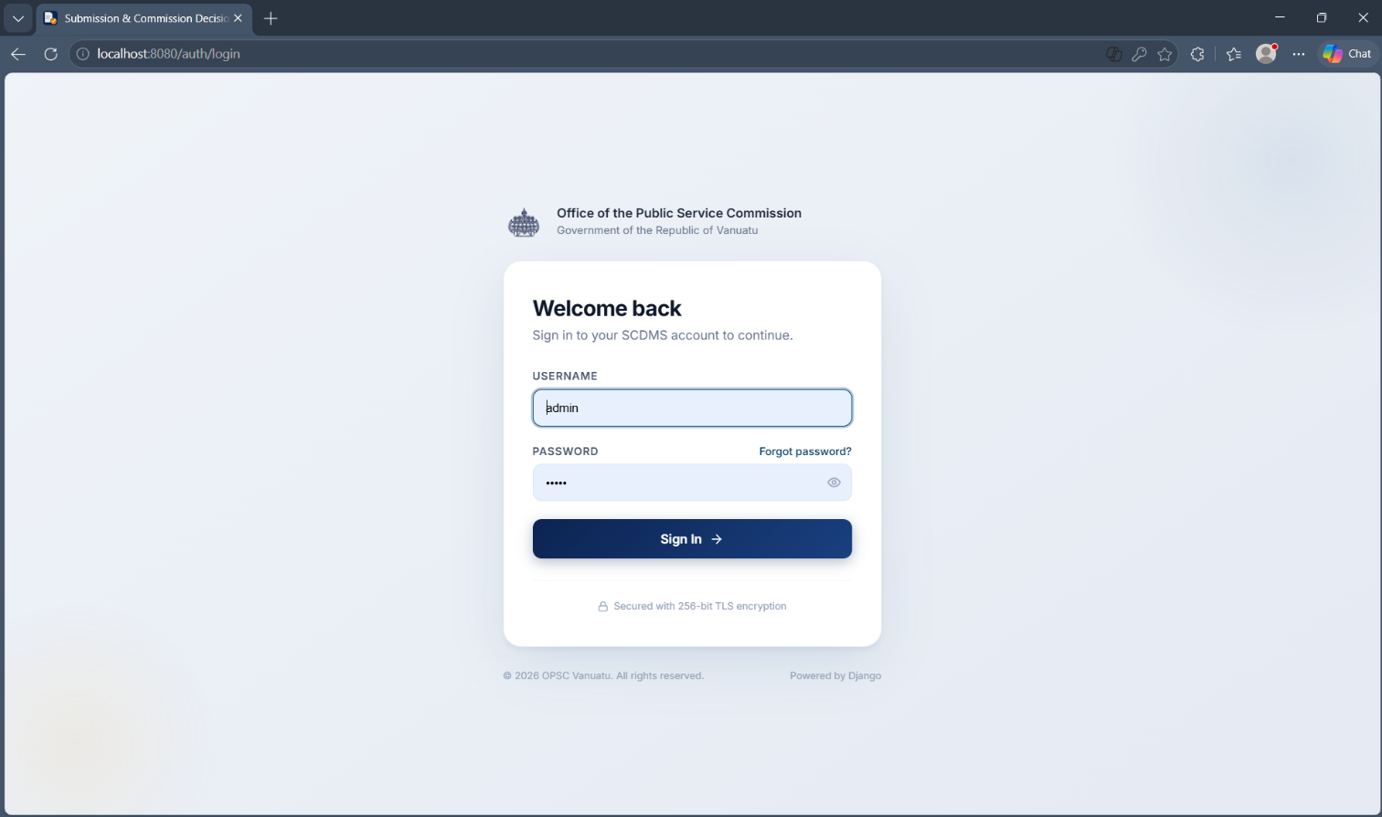
Login Screen

Dashboard (light & dark mode)
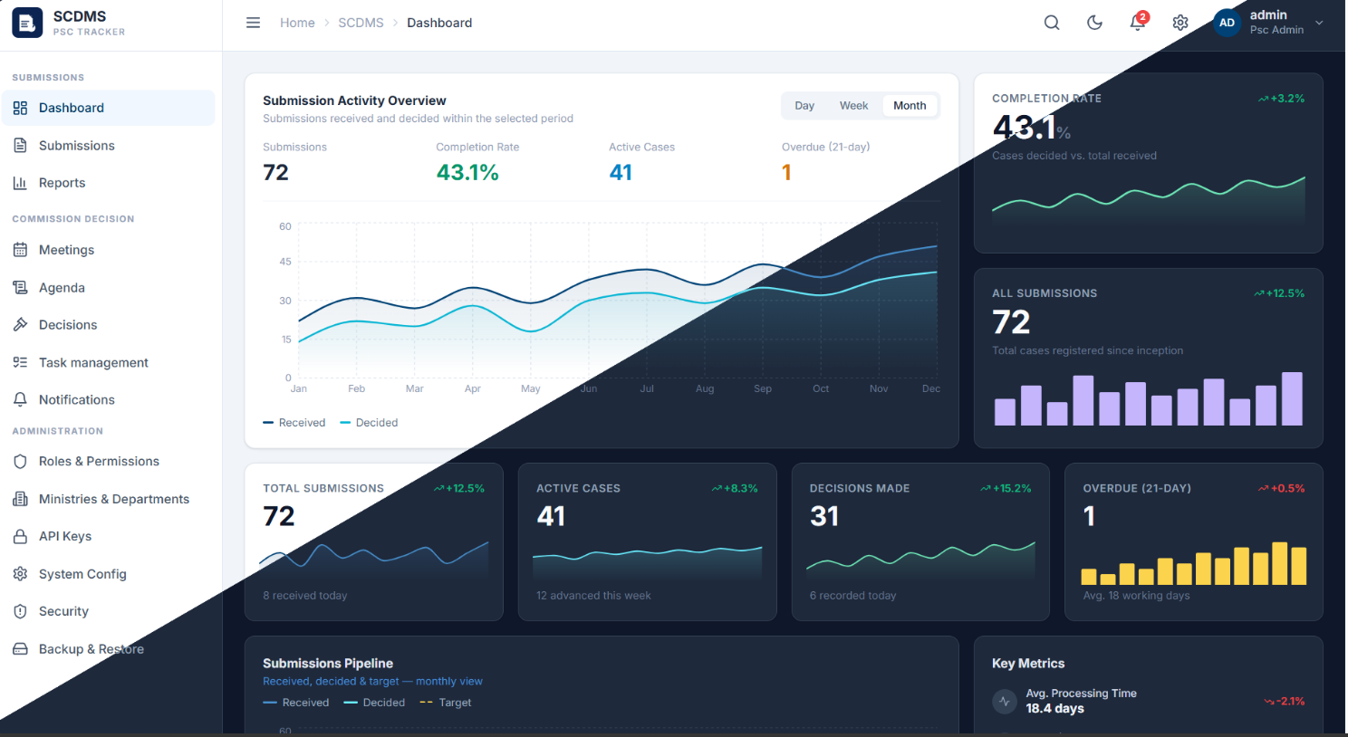
Roles & Permissions
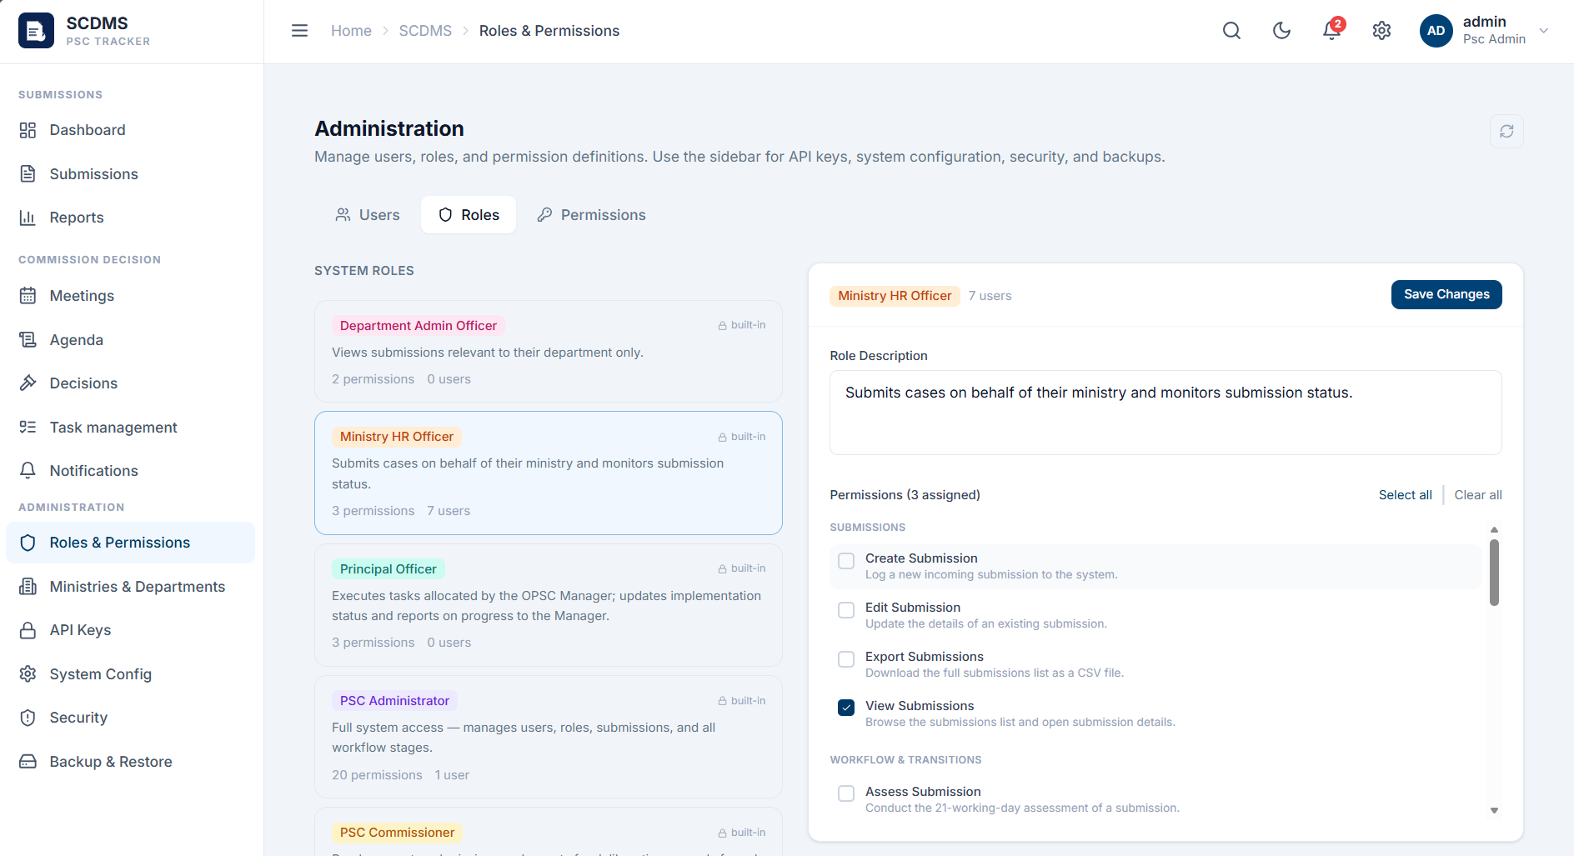
API Keys
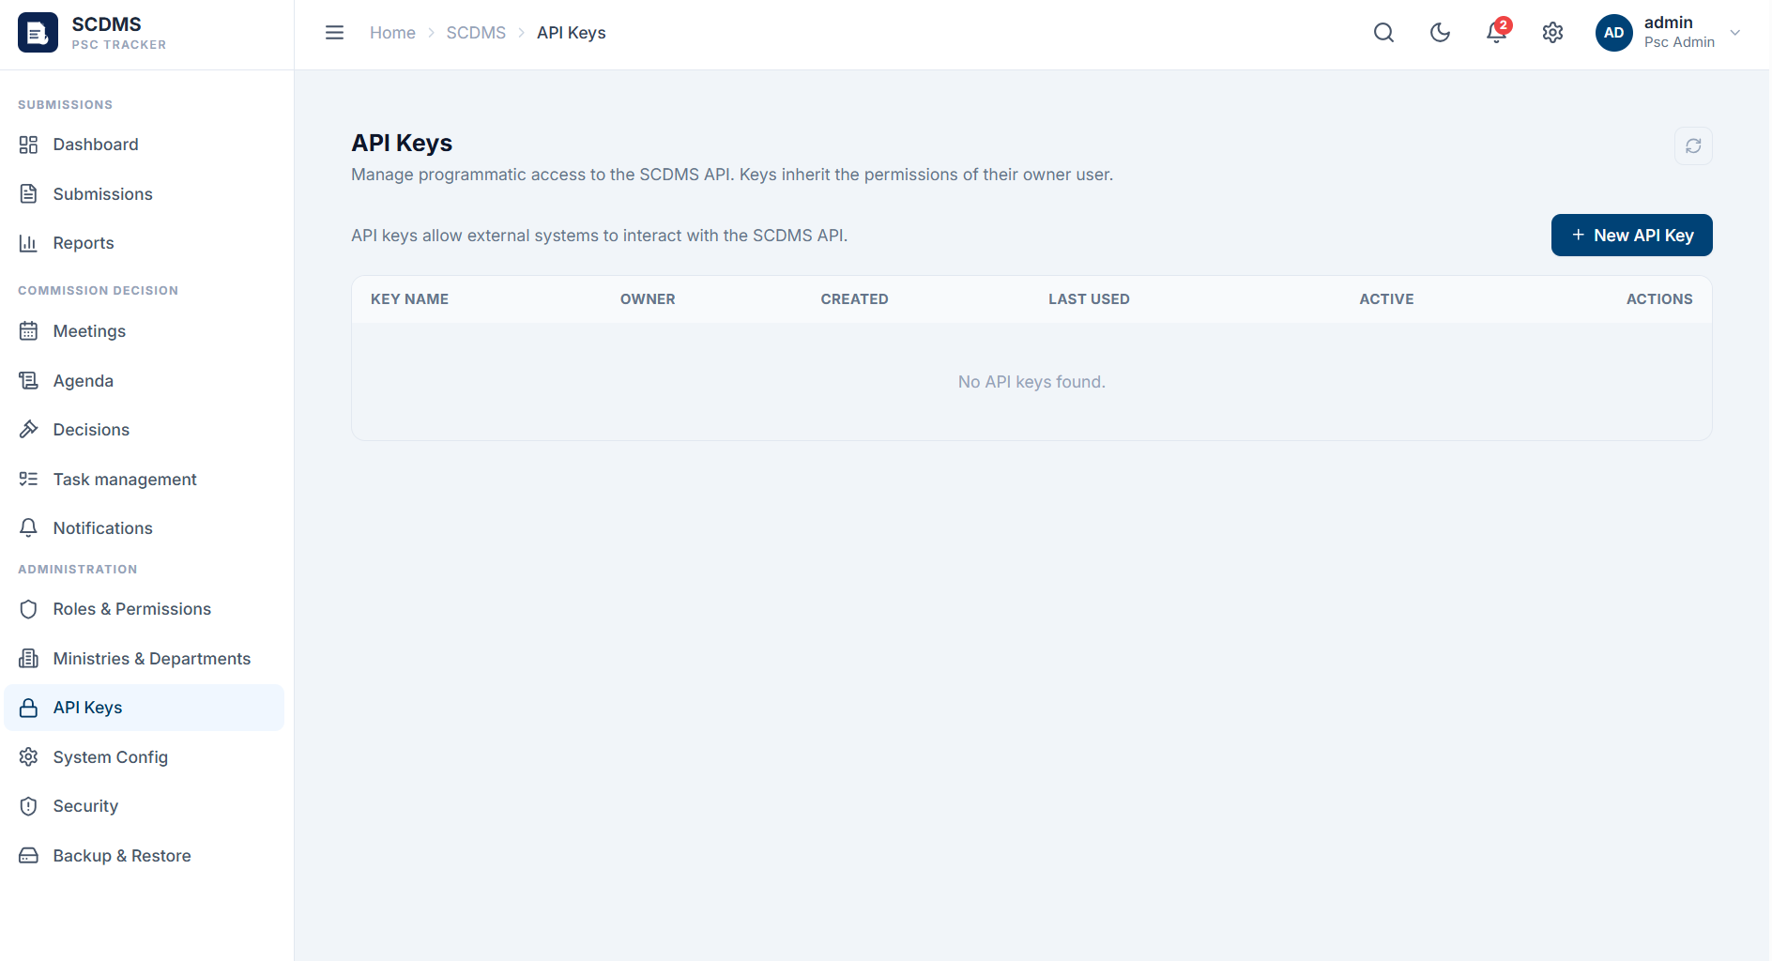
2FA using Microsoft Authenticator
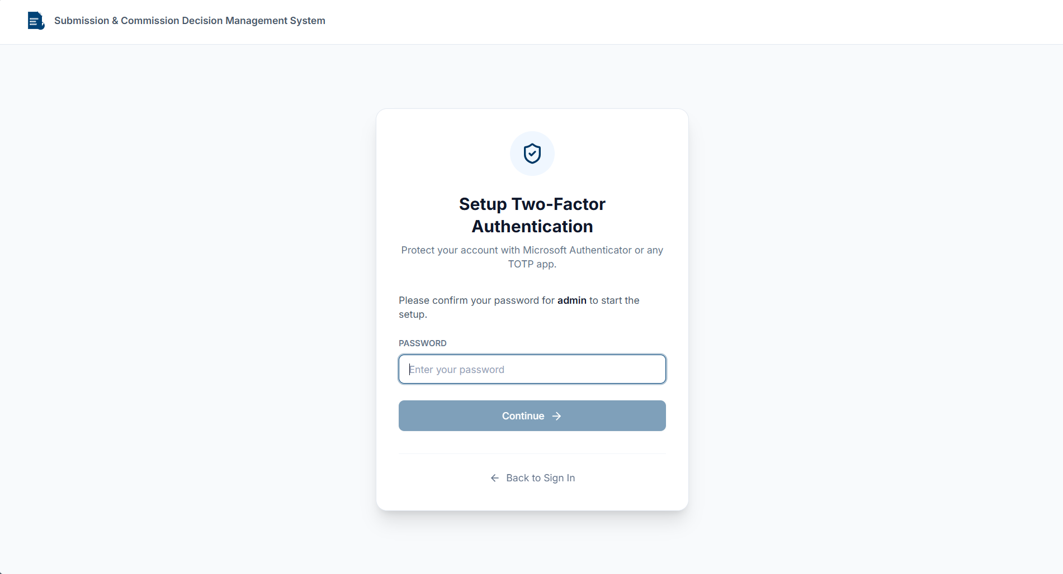
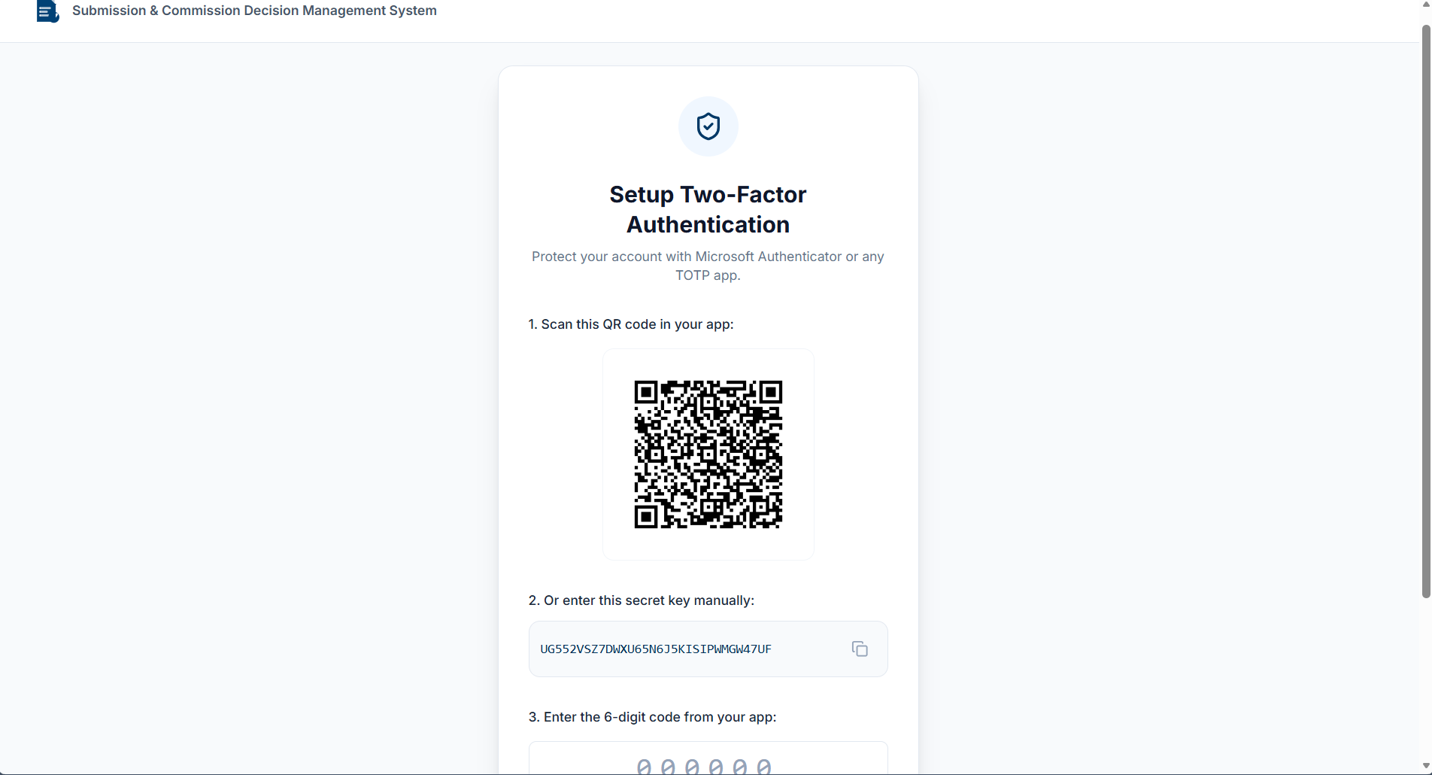
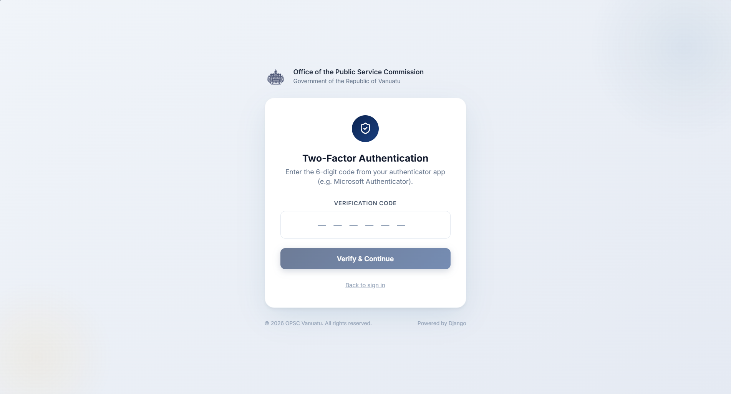
Password Policy and Account Lockout & Rate Limiting
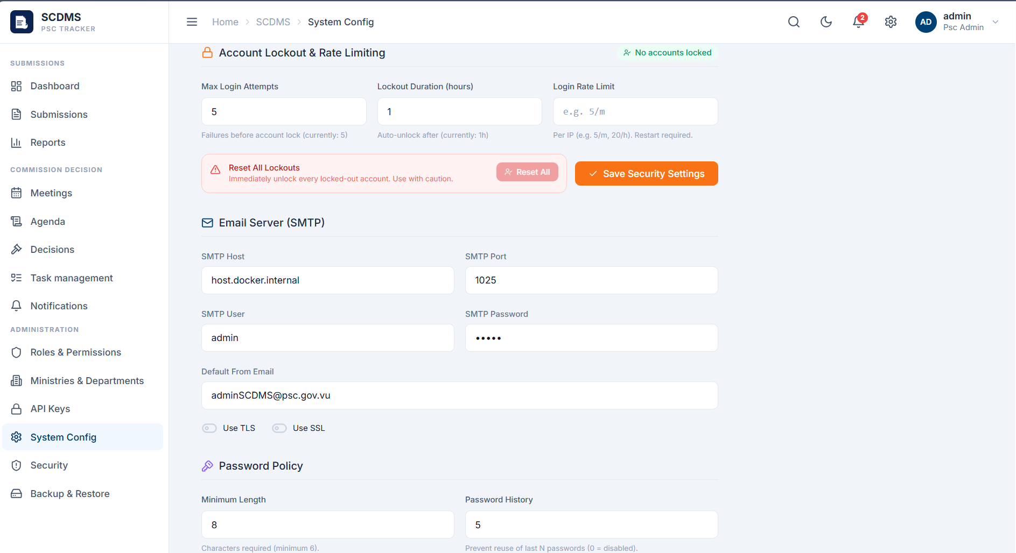
Audit Trail
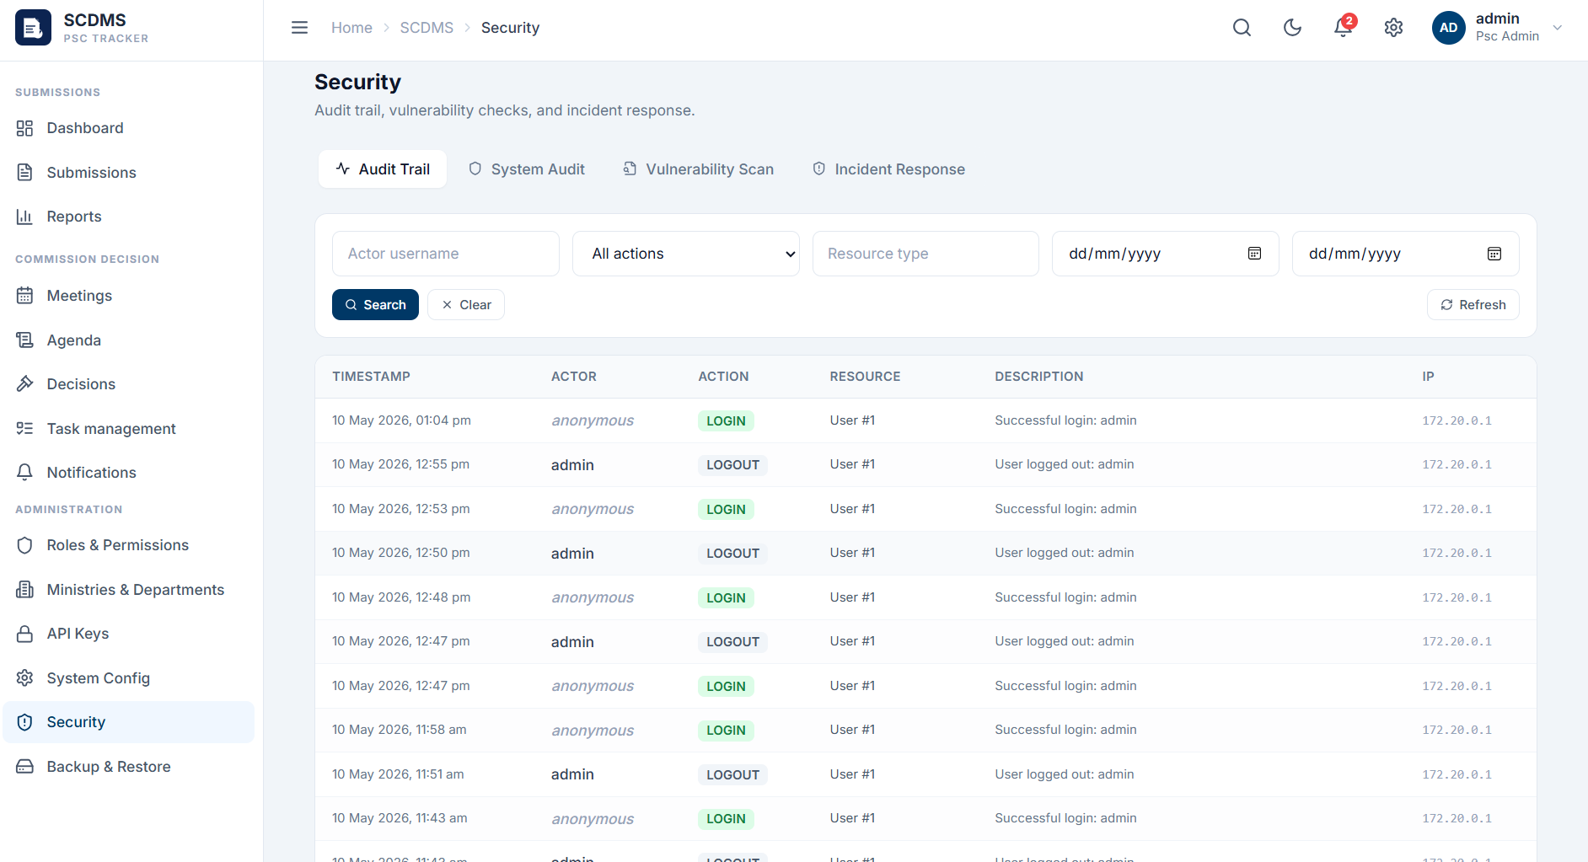
System Audit
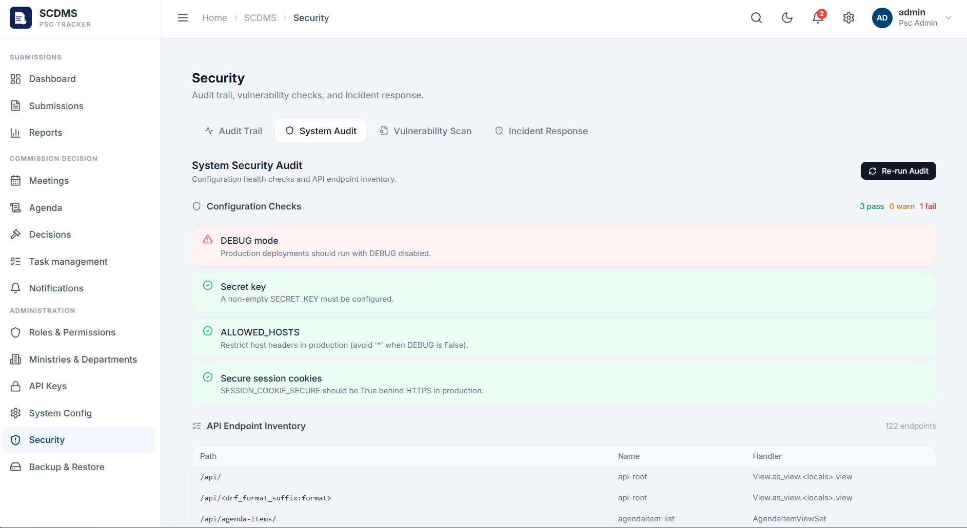
Vulnerability Scan
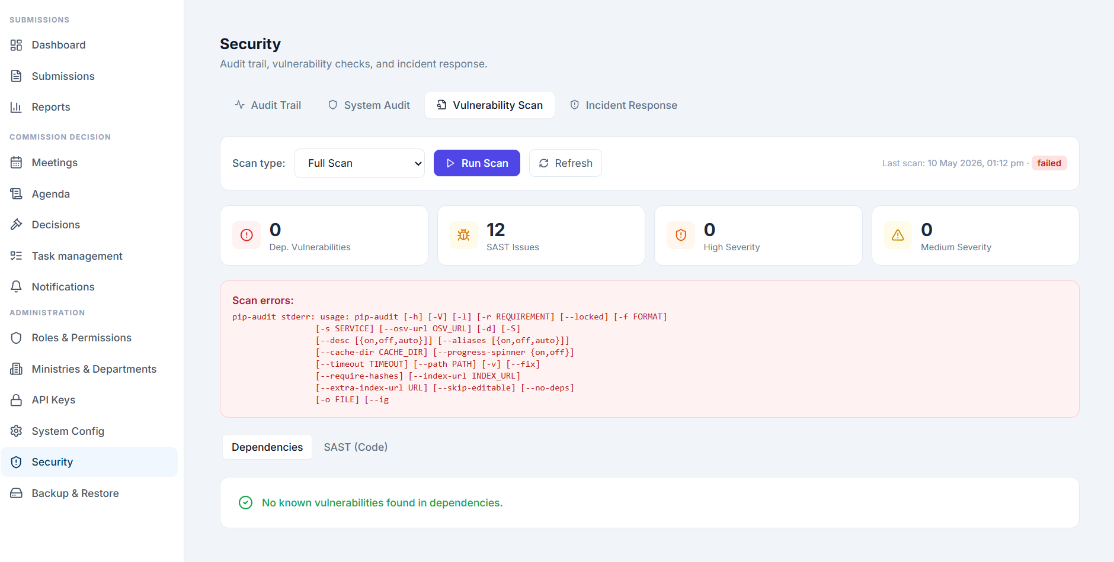
Incident Response
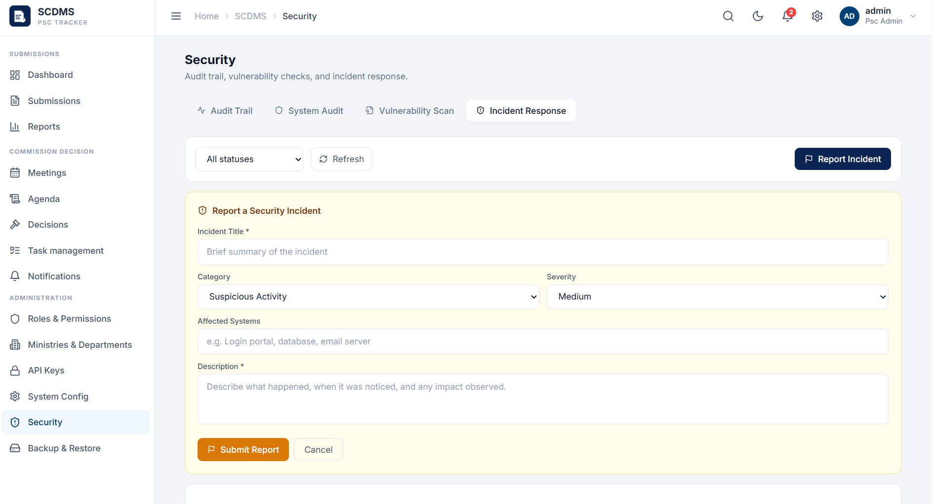
Backup & Restore
